U25AI055
DSA Lab-11
- Representation of binary tree
Output:
- Tree traversal

Output:
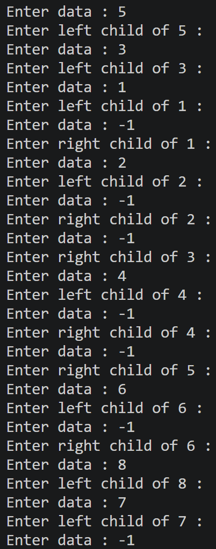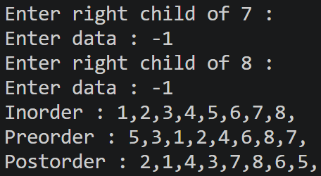
- BST – Insertion

Output:
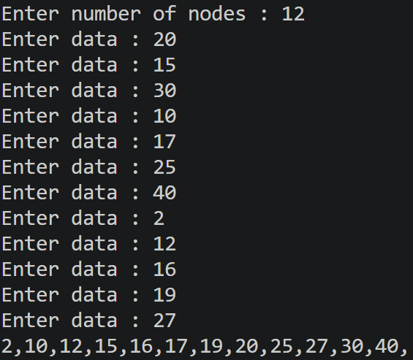
- BST – Searching

Output:
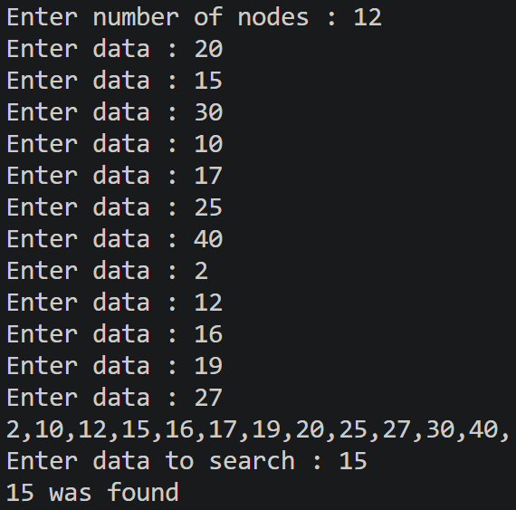
- BST – Deletion

Output:
